INTERFACE CONTROL DOCUMENT
VERSION 1.2.0

VIP Services

Version# | Implemented By | Date | Description
1.0.0 | - | 07/03/2023 | Version 1.0.0 API Method names as follows  - “Service Packages List”  - “Buy Package”  - “Confirm Used”
1.2.0 | - | 26/04/2023 | Update field in  “Service Packages List”

Introduction
- SECRET_KEY *must be requested from the service provider
- PUBLIC_KEY *must be requested from the service provider
To encode the X-API-KEY you will use SECRET KEY with the timestamp as follows:
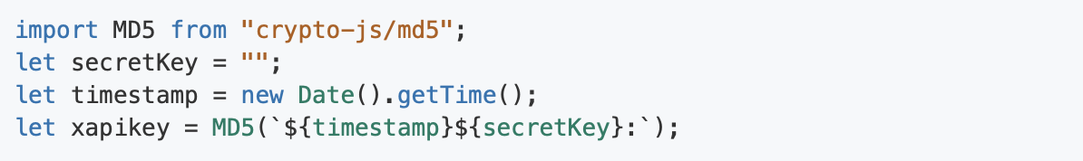
When you get the X-API-KEY, you can set the value in the header.
- X-API-KEY :
- timestamp
- key : Is PUBLIC_KEY must be requested from the service provider
The example code is :
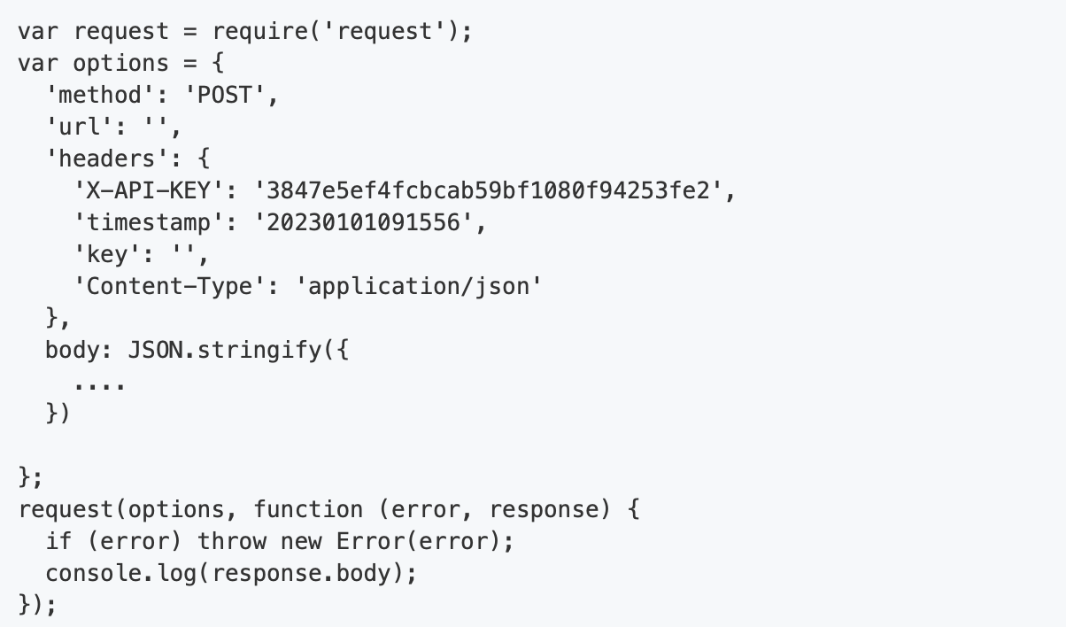

APIs to call from WeGoThailand to VIP Backend

Input:
1. Service Packages List - GET

No. | Field Name | Field Type | Field Size | Required | Field Description | Sample Data
1. | X-API-KEY | String |  | Yes | To encode the X-API-KEY you will use SECRET KEY with the timestamp | Header key X-API_KEY = 3847e5ef4fcbcab59bf1080  f94253fe2
2. | timestamp | String |  | Yes | The current time of an event that a computer records | Header key timestamp= 20230101091556
3. | key | String |  | Yes | Is PUBLIC_KEY must be requested from the service provider | Header key key=
4. | category | String |  | Yes | Filter category of package. | SERVICE
5. | Lang | String |  | Yes | Languages | EN

Output:
1. Service Packages List

No. | Field Name | Field Size | Field Type | Required | Field Description | Sample
1. | status |  | String | Yes | Response status
2. | message |  | String | Yes | Response message
3. | result |  | Array of Object | Yes
3.1 | package_code |  | String | Yes
3.2 | package_category |  | String | Yes |  | SERVICE
3.3 | package_name |  | String | Yes
3.4 | package_detail |  | String | Yes |  | VIP Services
3.5 | package_price_thb |  | String | Yes |  | 2700.00
3.6 | package_price_usd |  | String | Yes |  | 79.00
3.7 | package_price_cny |  | String | Yes |  | 540.00
3.8 | terms_of_use |  | String | Yes
3.9 | package_image |  | String | Yes |  | https://xxxx.com/xxxx.jpeg
3.10 | ref_link |  | String | Yes |  | https://xxxx.com/xxxx.pdf

Input:
- Buy Package– POST

No. | Field Name | Field Type | Field Size | Required | Field Description | Sample Data
1. | X-API-KEY | String |  | Yes | To encode the X-API-KEY you will use SECRET KEY with the timestamp | Header key X-API_KEY = 3847e5ef4fcbcab59bf1080  f94253fe2
2. | timestamp | String |  | Yes | The current time of an event that a computer records | Header key timestamp= 20230101091556
3. | key | String |  | Yes | Is PUBLIC_KEY must be requested from the service provider
4. | PaymentReceiptRefNumber | String |  | Yes | Unique identifier for the individual applications payment
5. | WebReferenceNumber | String |  | Yes | Unique identifier provided by VFS for every application
6. | SalutationId | Int32 |  | Yes | Id of Salutation master
7. | GivenName | String |  | Yes | First name
8. | SurName | String |  | Yes | Last name
9. | MiddleName | String |  | No | Middle name
10. | PassportNumber | String |  | Yes | Passport Number
11. | ArrivalAirportId | Int32 |  | Yes | Id of Arrival Airport master
12. | ArrivalDate | String |  | Yes | Date of arrival. Format: YYYY-MM-DD
13. | ArrivalTime | String |  | No | Time of arrival. Format: HH:MM
14. | ArrivalFlightNumber | String |  | Yes | Arrival flight number
15. | ArrivalAirlinesId | Int32 |  | Yes | Id of Arrival Airlines master
16. | PackageCode | String |  | Yes | Package Code form Service Package List | SVR-010
17. | PackagePriceTHB | double |  | Yes | Package Price (Baht)

Output:
2. Buy Package

No. | Field Name | Field Size | Field Type | Required | Field Description | Sample
1. | success |  | String | Yes | Response status
2. | Message |  | String | Yes | Response message
3. | result |  | Object | Yes
3.1 | paymentReceiptRefNumber |  | String | Yes |  | 2021070900010-G25352342
3.2 | webReferenceNumber |  | String | Yes |  | W02275799721029
3.3 | TransactionID |  | String | Yes |  | VIP-01_TRN23030000001X

APIs to call from VIP Backend to WeGoThailand

Input:
3. Confirm Used - GET

No. | Field Name | Field Type | Field Size | Required | Field Description | Sample Data
1. | X-API-KEY | String |  | Yes | To encode the X-API-KEY you will use SECRET KEY with the timestamp | Header key X-API_KEY = 3847e5ef4fcbcab59bf1080  f94253fe2
2. | timestamp | String |  | Yes | The current time of an event that a computer records | Header key timestamp= 20230101091556
3. | key | String |  | Yes | Is PUBLIC_KEY must be requested from the service provider
4. | PassportNumber | String |  | Yes | Passport Number
5. | TransactionID | String |  | Yes | Reference ID from Buy method
6. | ConfirmBy | String |  | Yes | Name of Staff that confirm sim
7. | Remark | String |  | No | Remark

Output:
3. Confirm Used

No. | Field Name | Field Size | Field Type | Required | Field Description | Sample
1. | success |  | String | Yes | Response status
2. | message |  | String | Yes | Response message

